PH 205 – Homework Assignment #2

**Due on Monday, September 15th.**

For this assignment, please make your plots for Exercises 2, 3, and 4 by hand. Then take nice, legible pictures of these plots and insert them in a Word document. For Exercises1, please type your answers. Make sure your name is written on the top of the assignment. Once you have completed the work, save it as “LastName_HW #.docx” (e.g. Einstein_HW2.docx) and upload it to the Canvas assignment page.

# Exercise 1

In the *Useful Resources* module on Canvas there are items on Growth Mindset and Stereotype Threat. Please read the information provided with both of these items.

### a) This is a typical Biostatistics course, in that you should expect a challenging course where you will have to work hard in order to succeed. The information on Growth Mindset mentions “dedication & hard work” as paths to success. With that in mind, please list 3 ideas for things you plan/intend to do this semester that will help you succeed in this course and grow your mind.

1.I will review class materials regularly instead of only before exams, so that i can build a deeper and more lasting understanding of concepts.

2.I will actively participate in class discussion and group work , even if i am unsure of my answer , because mistakes are opportunities to learn.

3. I will seek help early,either from the instructor ,classmates , or additional resources(office hours , tutoring),instead of waiting until I fall behind.

### b) Based on your reading of the Stereotype Threat document, it should be clear that this is something that anyone can experience (I certainly have). What is a consequence of Stereotype Threat? How can someone reduce the threat?

Answer: For consequence: Stereotype Threat can cause increased anxiety and reduced performance, because individuals may confirm negative stereotypes about their group.One way to reduce the threat is to remind people that intelligence and ability can be developed through effort and learning, rather than being fixed traits.

Each and every one of you has the potential to succeed in this course. I am here to help you along the way. I hope that you always feel comfortable participating in class and asking all of your questions, no matter how “dumb” you may think they are (there is no such thing as a dumb question).

Our classroom will be inclusive, where everyone will be treated with respect. Learning requires taking risks that often require guessing an answer or an approach to solving a problem. Mistakes are the key moments where learning begins, thoughts in logic are corrected and core memories are formed. Everyone in this course will make mistakes so do not be embarrassed when you are wrong.

# Exercise 2:

Despite the intense anti-smoking campaigns sponsored by both federal and private agencies, smoking continues to be the single-biggest cause of preventable death in the United States. How has the tobacco use of high school students changed over the past few years? For each of several tobacco products, high school students were asked whether they had used each of them in the past 30 days. Here are some of the results[1]:

|  | Year | | | | | | | | |
| --- | --- | --- | --- | --- | --- | --- | --- | --- | --- |
| Product | 2011 | 2012 | 2013 | 2014 | 2015 | 2016 | 2017 | 2018 |
| Any tobacco product | 24.3 | 23.3 | 22.9 | 24.6 | 25.3 | 20.2 | 19.6 | 27.1 |
| Cigarettes | 15.8 | 14 | 12.7 | 9.2 | 9.3 | 8.0 | 7.6 | 8.1 |
| Cigars | 12.6 | 11.6 | 11.9 | 8.2 | 8.6 | 7.7 | 7.7 | 7.6 |
| Pipes | 4.5 | 4.0 | 4.1 | 1.5 | 1.0 | 1.4 | 0.8 | 1.1 |
| Smokeless tobacco | 7.3 | 6.4 | 5.7 | 5.5 | 6.0 | 5.8 | 5.5 | 5.9 |
| E-cigarettes | 1.5 | 2.8 | 4.5 | 13.4 | 16 | 11.3 | 11.7 | 20.8 |

The first row of the table gives the percentages of high school students who had used any tobacco product, ­including cigarettes, pipes, cigars, smokeless tobacco, e-cigarettes, hookahs, snus, bidis, or dissolvable tobacco, in the past 30 days for the years 2011–2018. The remaining rows give the percentage of high school students using the most common tobacco products in each of these years.

### Using the information in the first row of the table, draw a bar chart (by hand) that shows the change in the use of any tobacco product between 2011 and 2018. How would you describe the pattern of change in this usage?

ANSWER: Between 2011 and 2013, the percentage of high school students using any tobacco product declined regularly from 24.4% to 22.9^%.In 2014 to 2015 , the percentage increased slightly , reaching 25.3% in 2015. However ,in 2016 and 2017,usage dropped sharply to below 20%.By 2018, there was a big rise to 27.1%,which was the highest value from 2011 to 2018. In conclusion, the trend shows fluctuations with a first decline , a sharp decrease and a sudden increase by 2018.

# Exercise 3:

Fatty acids, despite their unpleasant name, are necessary for human health. Two types of essential fatty acids, called omega-3 and omega-6, are not produced by our bodies and so must be obtained from our food. Food oils, widely used in food processing and cooking, are major sources of these compounds. There is some evidence that a healthy diet should have more omega-3 than omega-6. The table below gives the ratio of omega-3 to omega-6 in some common food oils[2]. Values greater than 1 show that an oil has more omega-3 than omega-6.

| **Oil** | **Ratio** | **Oil** | **Ratio** |
| --- | --- | --- | --- |
| Perilla | 5.33 | Flaxseed | 3.56 |
| Walnut | 0.20 | Canola | 0.46 |
| Wheat germ | 0.13 | Soybean | 0.13 |
| Mustard | 0.38 | Grape seed | 0.00 |
| Sardine | 2.16 | Menhaden | 1.96 |
| Salmon | 2.50 | Herring | 2.67 |
| Mayonnaise | 0.06 | Soybean, hydrogenated | 0.07 |
| Cod liver | 2.00 | Rice bran | 0.05 |
| Shortening (household) | 0.11 | Butter | 0.64 |
| Shortening (industrial) | 0.06 | Sunflower | 0.03 |
| Margarine | 0.05 | Corn | 0.01 |
| Olive | 0.08 | Sesame | 0.01 |
| Shea nut | 0.06 | Cottonseed | 0.00 |
| Sunflower (oleic) | 0.05 | Palm | 0.02 |
| Sunflower (linoleic) | 0.00 | Cocoa butter | 0.04 |

### Make a histogram of these data (by hand), using bins bounded by the whole numbers from 0 to 6 (i.e., 0, 1, …, 6).

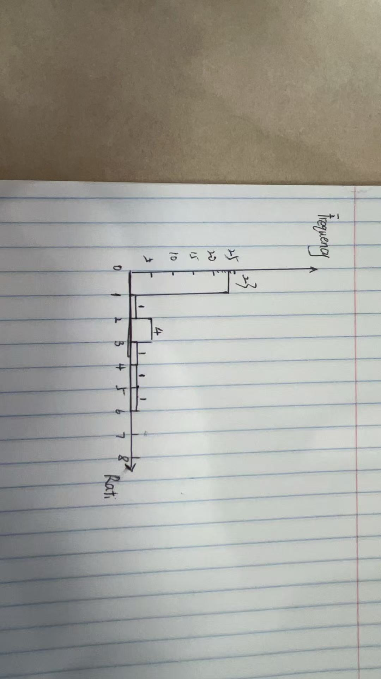

### What is the shape of the distribution? How many of the 30 food oils have more omega-3 than omega-6? What does this distribution suggest about the possible health effects of modern food oils?

Answer:The distribution is right-skewed. 6 foods have more omega-3 than omega-6. The modern food diet is not balanced, because in most cases people consume more omega-6 than omega-3. Since common foods usually contain more omega-6, people should choose special foods that provide higher omega-3, such as fish oils or flaxseed oil, to improve health balance.

# Exercise 4:

In 1980, approximately 20% of adults aged 18–34 were considered minorities, reporting their ethnicity as other than non-Hispanic White. By the end of 2013, that percentage had more than doubled. How are minorities between the ages of 18 and 34 distributed in the United States? In the country as a whole, 42.8% of adults aged 18–34 are considered minorities, but the states vary from 8% in Maine and Vermont to 75% in Hawaii. The table below presents the data for all 50 states and the District of Columbia[3].

| **State** | **Percent** | **State** | **Percent** | **State** | **Percent** |
| --- | --- | --- | --- | --- | --- |
| Alabama | 39 | Louisiana | 45 | Ohio | 23 |
| Alaska | 40 | Maine | 8 | Oklahoma | 37 |
| Arizona | 51 | Maryland | 52 | Oregon | 27 |
| Arkansas | 31 | Massachusetts | 31 | Pennsylvania | 26 |
| California | 67 | Michigan | 28 | Rhode Island | 31 |
| Colorado | 35 | Minnesota | 23 | South Carolina | 41 |
| Connecticut | 39 | Mississippi | 48 | South Dakota | 19 |
| Delaware | 23 | Missouri | 23 | Tennessee | 30 |
| Florida | 52 | Montana | 15 | Texas | 61 |
| Georgia | 51 | Nebraska | 23 | Utah | 22 |
| Hawaii | 75 | Nevada | 54 | Vermont | 8 |
| Idaho | 20 | New Hampshire | 11 | Virginia | 41 |
| Illinois | 42 | New Jersey | 51 | Washington | 34 |
| Indiana | 23 | New Mexico | 67 | West Virginia | 9 |
| Iowa | 16 | New York | 48 | Wisconsin | 22 |
| Kansas | 27 | North Carolina | 41 | Wyoming | 18 |
| Kentucky | 17 | North Dakota | 15 | District of Columbia | 53 |

### Use R to find the five-number summary of this distribution. The dataset (**minorities.csv or minorities.rds**) is given on Canvas. Include the commands that you used in R to produce the five-number summary.

```M1<-read.csv("/Users/zhaozhan/Downloads/Tufts\ University/principles\ of\ Biostatistics/week2/h2/minorities.csv")

summary(M1)```

State PctMinority

Length:51 Min. : 7.80

Class :character 1st Qu.:22.15

Mode :character Median :31.30

Mean :33.90

3rd Qu.:46.15

Max. :75.00

### Are there any outliers in this distribution? Show your calculations.

No outliers in this distribution.

M1<-read.csv("/Users/zhaozhan/Downloads/Tufts\ University/principles\ of\ Biostatistics/week2/h2/minorities.csv")

summary(M1)

q1 <- quantile(M1$PctMinority, 0.25, names = FALSE)

q3 <- quantile(M1$PctMinority, 0.75, names = FALSE)

IQR_1<-IQR(M1$PctMinority)

low1<-as.numeric(q1-1.5*IQR_1)

high1<-as.numeric(q3+1.5*IQR_1)

outlier_M1<-M1$PctMinority[M1$PctMinority<low1|M1$PctMinority>high1]

b1<-boxplot(M1$PctMinority, main="Minority % by State")

Out_verify1<-boxplot.stats(M1$PctMinority)$out

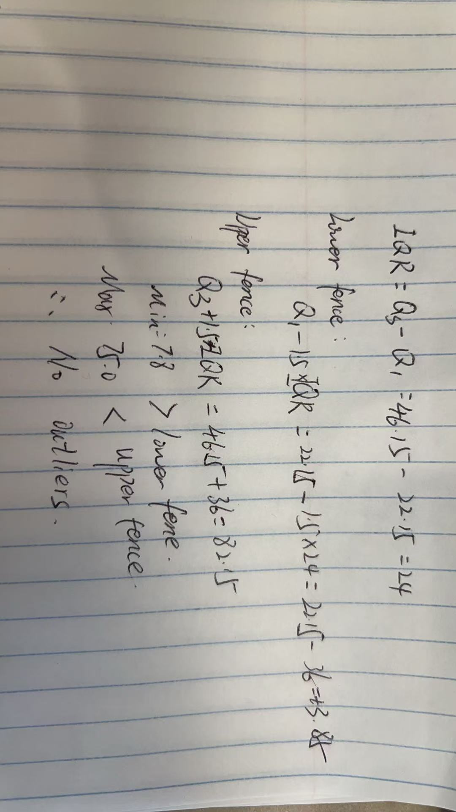

### Use the five-number summary to make a box-plot of these data (by hand).

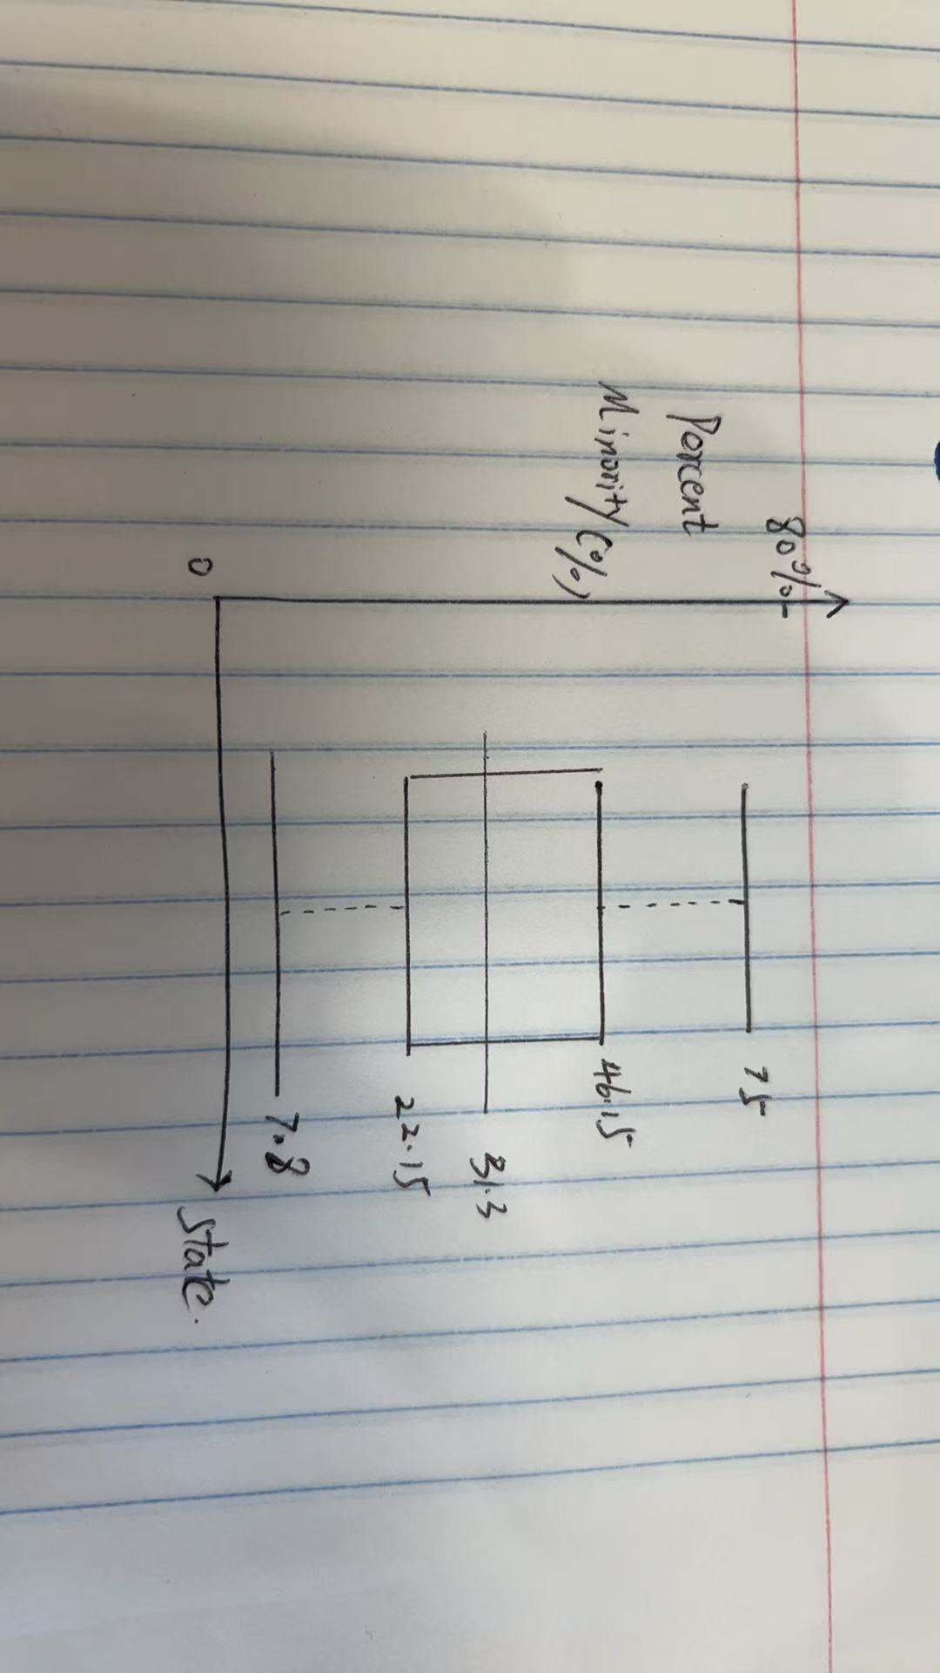

1. Centers for Disease Control and Prevention publishes yearly reports on “Tobacco Use Among Middle and High School Students—United States,” at <https://www.cdc.gov/tobacco/data_statistics/fact_sheets/youth_data/tobacco_use/index.htm> .
2. National Institutes of Health. The data for ratio of omega 3 to omega 6 fatty acids in food oils are no longer available; NIH now uses a new measure to compare amounts of these substances.
3. From Young Adults Then and Now at <https://census.socialexplorer.com/young-adults/#/> .